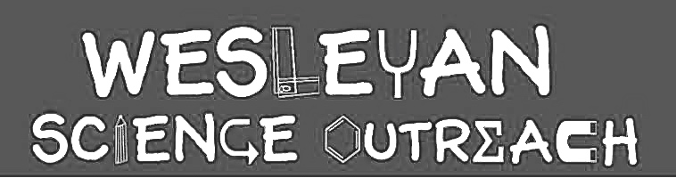

Andie Kleeman
3/5/16

Flight Science

This lesson will introduce students to the science behind flight. They will learn the four forces of flight and how each acts on an aircraft. For manmade aircrafts, they will learn about Bernoulli’s Principle and how it can create lift and propellers and how they create thrust. Then they will be able to make their own paper gliders and test them.

Material List

- Four forces of flight worksheet
- Small pieces of paper for Bernoulli’s principle
- Diagram of wing/Bernoulli’s principle
- Propellers with dowels attached to them
- Lots of paper
- Markers, crayons, colored pencils to decorate paper airplanes
- A space to test paper airplanes

Activities

1. Introduction to Flight: the Four Forces of Flight
Duration: 5 min

Ask the students if they’ve ever wondered what it would be like to fly. Ask them for some examples of things that fly. How many of them have been in an airplane? What about a helicopter, a hot air balloon, glider, hang glider, or rocket ship? Explain that today we’re going to learn about the science of flight. Pass out a picture of an airplane. There are four forces involved in flight, and we must master them first in order to learn how airplanes and other things that fly were engineered. The first force is weight. This is a downward force caused by gravity (remind them of our lesson of forces from the fall!) that causes the aircraft to want to go down towards the earth. The second force is lift. This force is upward and counteracts the weight to enable to aircraft to fly. The third force is thrust. It is forwards and causes the aircraft to move not only up but also forward. The fourth force is drag. It acts against thrust, backwards, and is the air pushing back on the aircraft as it moves forwards. As we explain this, have the kids label the four forces in their diagram of a plane.

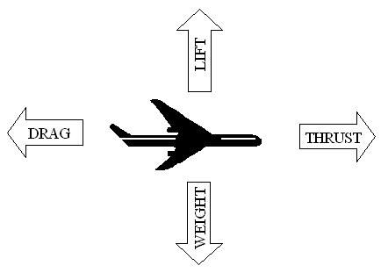

2. Bernoulli’s Principle: Lift
Duration: 10 min

Ask the students if they know how planes, birds, or other aircrafts achieve lift, or overcome their weight to get up in the air. Explain that when air moves faster or slower, it has an impact on the pressure of the air. Hand out pieces of paper to the students. Ask them for a hypothesis of what the paper will do when they hold it right below their mouths and blow over it. Now try the experiment. Why does the paper go up?? This is Bernoulli’s principle at work, and essentially how planes fly. Explain that as you blow air across the top of the paper, the air moves faster and then has a lower pressure than the air moving slower under the paper. The higher pressure under the paper causes it to lift. Show the students the picture of an airplane wing design and how it causes air to move faster over the top of the wing, decreasing the pressure, and lifting the plane.
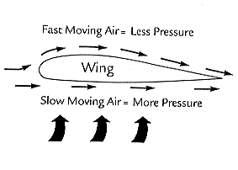

3. Propellers: Thrust
Duration: 10 min

While wings give an airplane lift and cause it to move upward, it does not make it go forward. Different aircrafts have different mechanisms to propel them forward. Ask the students if they know any examples. One we will be learning about today is a propeller. A propeller is a rotating object (like a fan) that pushes air backwards to push the plane forwards. Give out little propellers on sticks to the kids. Show them a simple demonstration: holding the stick between your palms, propeller up, spin the stick several times before releasing it upwards. The whole propeller and stick should go up into the air high before coming back down, showing that propellers, when spinning, create thrust. [For older students, you can explain that jet airplanes instead uses fuel and chemical reactions for thrust. They burn the fuel to create high pressure in the plane, which is then push out of the back of the plane, propelling it forward.]

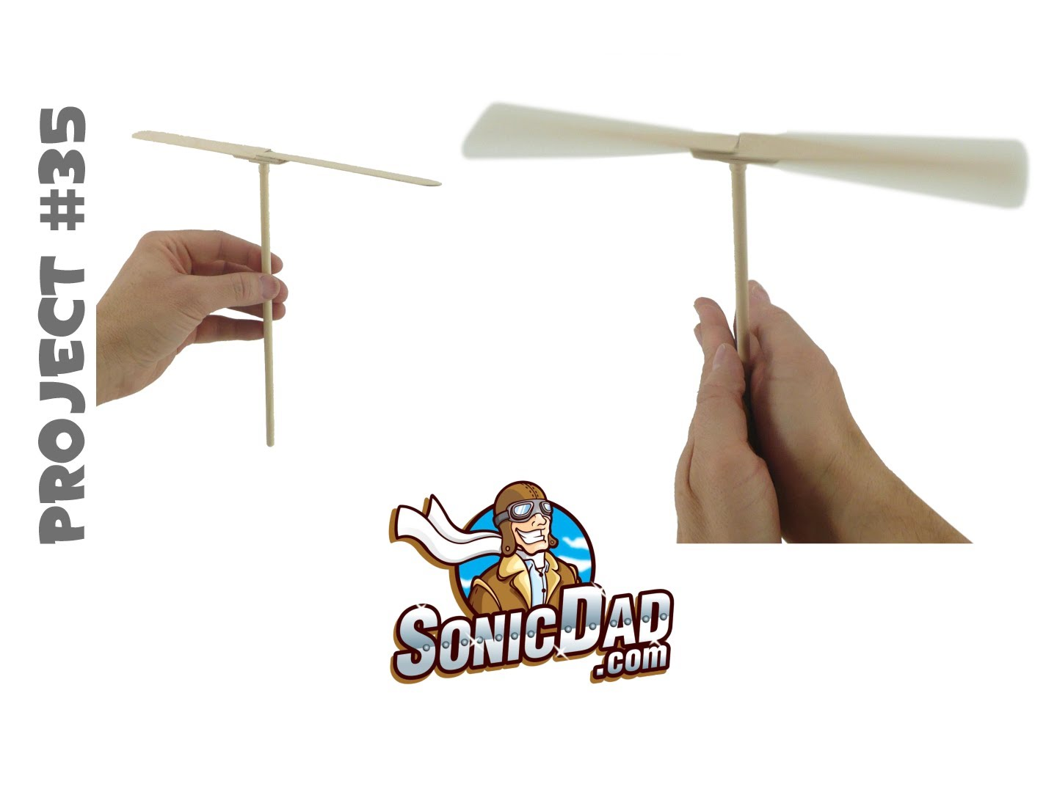

4. Making Paper Airplanes
Duration: 20 min

Hand out a piece of paper to each of the kids. If they have their own paper airplane design and want to test it, they can. If not, together we will show them step by step how to make a great paper airplane.
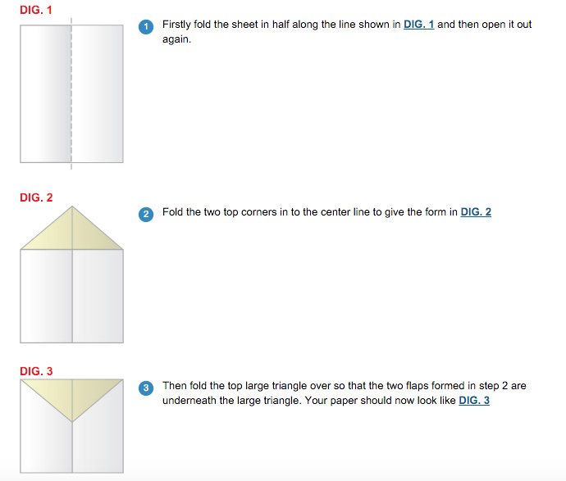
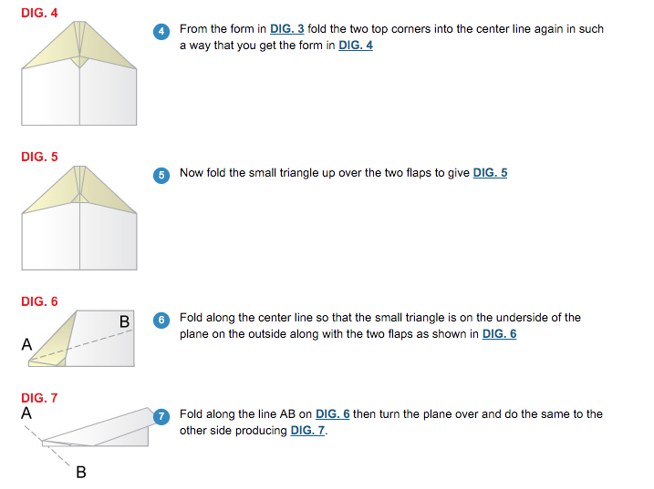
http://www.paperairplanes.co.uk/nickplan.php#instructions

Once they’ve made their airplanes, they can test them and make adjustments to see how far and how straight they can fly them. **Make sure to have a test area so the students are throwing them at each other.**

Conclusion

Students should understand the four forces of flight, drag, thrust, lift, and weight, and how the counteract each other. They will examine Bernoulli’s principle and understand that the shape of an aircraft or bird’s wing makes the air move faster over the top of the wing, decreasing the pressure, therefore lifting the aircraft or bird. They should also know that there are different ways aircrafts achieve lift, propellers being on of the ways.

Instructor Comments

